**Project Design Phase-I**

**Solution Architecture**

|  |  |
| --- | --- |
| Date | 20 November 2023 |
| Team ID | 51C820FC99E50B82591A742E901A0B013D |
| Project Name | Ethereum decentralized identity smart contract |

Maximum Marks 4 Marks

**Solution Architecture Diagram:**

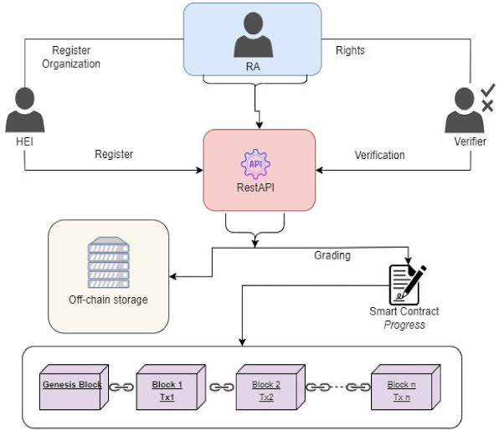

**Steps to complete the project**

**Step 1: Define Requirements**

* Outline the specific features and functionalities your decentralized identity smart contract needs.
* Identify the types of information to be stored, access requirements, and any user interactions.

**Step 2: Choose Standards**

* Select Ethereum standards that fit your requirements, such as ERC-725 for identity management and ERC-735 for claim management.
* Understand the structure and functions these standards provide for decentralized identity.

**Step 3: Smart Contract Logic**

* Develop the core logic of your smart contract based on the chosen standards.
* Implement functions for creating identities, updating information, and verifying claims.
* Consider the flow of interactions within the contract and how different actions will be processed.